**Graph/Map/Image**

The image describes a line graph that talks about .[Topic].

It also provides information about the topic in different categories like .[].

It is clear from the image that A contributes the highest figure/ area which is ….

While B contributes the lowest figure/ area, which is….

After analyzing the image, it can be concluded that the image shows crucial information, strongly supported by important facts and figures, having great impacts of C and D.

Nói khoảng 30s. Phải bấm next.

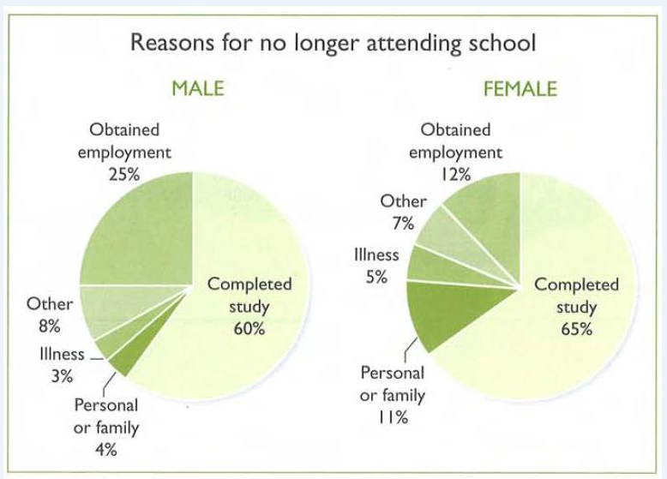

**Topic: 1 dòng**

Phân loại, nó những cái quan trọng. 5-6 cái thôi

_Chữ to in đậm

_ năm

_tháng